

User Guide

March 2020



Real Life

Life Changing

Changing Healthcare

Copyright

NAVVIS Coreo Home User Guide

Copyright © 2019 NAVVIS & Company, LLC. All rights reserved.

The information in this User Guide may change without notice.

Trademarks

We acknowledge all product names, trade names, or corporate names we mention in this User Guide to be the proprietary property of the registered owners.

Disclaimer

Names and personal information used in this document are purely fictitious and do not refer to real names or persons.

This User Guide is not guaranteed to be error-free and is provided "as is" without warranty of any kind, whether express, implied, or statutory. The User Guide may be inaccurate, incorrect, invalid, untrue, false, incomplete and/or misleading. The entire risk as to the quality, correctness, accuracy, or completeness of the content of this User Guide is with you. The author(s), owner(s), publisher(s), and administrator(s) of this User Guide, and applicable intellectual property owner(s) disclaim any and all warranties of any kind.

Disclaimer of Liability

The author(s), owner(s), publisher(s), and administrator(s) of this User Guide, and applicable intellectual property owner(s) disclaim any and all liability and in no event will any of those parties be liable to you or to any other party for damages, including, but not limited to, any direct, indirect, general, special, incidental, punitive, exemplary, or consequential damages (including, but not limited to, any losses sustained by you or third parties, procurement of substitute services, or business interruption), whether in contract, strict liability, tort (including negligence) or otherwise, arising out of any use of this User Guide or the content thereof or of any third-party website or content linked in any way from this User Guide, even if such damages (or possibility of such damages) are/were predictable or known to the author, owner, publisher, administrator, or any other party.

No part of this document may be reproduced or transmitted in any form or by any means, electronic or mechanical, for any purpose, without the express written approval of Navvis & Company, LLC.

Table of Contents

Preface 4

About Navvis Coreo Home 4

About Navvis Healthcare 4

Purpose of this Document 4

Intended Audience 5

Organization of the Document 5

Conventions 5

Browsers Versions for Coreo Home 6

Coreo Home–Patient Account 7

1 Patient Onboarding 8

2 Patient Profile 8

2.1 Edit Your Profile 8

3 Set Up Payments 16

4 Dashboard 18

4.1.1 Browse Providers 19

4.1.2 Engage Provider 20

4.1.3 Create and Post a Service Request 21

4.1.4 Visit(s) Schedule 27

4.1.5 Submit Feedback 32

4.2 Messaging 34

4.3 Video Conferencing 35

Coreo Home–Guardian Account 37

1 Guardian Onboarding 38

2 Guardian Profile 39

2.1 Guardian–Be a Guardian to the Individual that You Add 41

2.2 Individual–You Become an Individual Needing Services 45

3 Acting on Behalf of a Dependent Member 45

4 Glossary 46

5 Index 47

Preface

Welcome to the release of the NAVVIS Coreo Home User Guide.

About Navvis Coreo Home

NAVVIS Coreo View is a software platform that empowers users to manage the status and the flow of patients through Acute Care (AC), Post-Acute Care (PAC), and home networks.

Coreo View is HIPAA (Health Insurance Portability and Accountability Act) compliant and is available as a SaaS (Software-as-a-Service) cloud solution, enabling the management of patients with real-time data. Coreo View is part of the Coreo ecosystem, which allows cross-continuum care coordination and ensures seamless care transition.

The Coreo ecosystem includes the following applications as illustrated below:

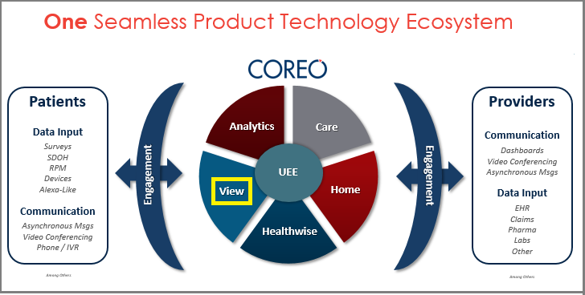

About Navvis Healthcare

Navvis Healthcare provides counsel to health systems, hospitals, and physician groups on the development of innovative, market-linked strategies to build future-ready health systems, cultivate tomorrow’s leaders, and strengthen strategic performance.

Purpose of this Document

This guide is the primary source of information about the Navvis Coreo Home application. It contains overviews, processes, and procedures to use the Coreo Home application effectively.

You can refer to the Navvis Unified Ecosystem Experience (UEE) User Guide and the Navvis Coreo View User Guide for additional sources of information.

Intended Audience

1. **Users**: The users of the Coreo Home application include the following personnel:

* Clinical staff and hospital administrators
* Employees, consultants, contractors, or agents of the clinicians or patients who have been invited by the clinician or patient to access and use the service to participate in the care of the patient
* Any other person involved in the care of the patient, including patient's care providers, patient's insurer or payer, or a social worker, or government agencies

1. **Administrator-users**: The Coreo Home administrator-users referred to as care team are assigned the task of managing other users of the Coreo Home application.

Organization of the Document

This document contains the following modules:

* Coreo View User Function
  + Module 1, “User Onboarding”
  + Module 2, “Home Screen Layout and Navigation”
  + Module 3, “Bed View”
  + Module 4, “Prioritized View”
  + Module 5, “Geo-Mapping View”
  + Module 6, “Using Filters and Themes”
  + Module 7, “Global Search and Local Search”
  + Module 8, “Patient Summary”
  + Module 9, “Flagging Patient Records”
  + Module 10, “General Reports”
  + Module 11, “Synchronizing Patient View between UEE Applications with Coreo View”
* Exhibit: Coreo View Administrative Guide
  + Module 1, “Coreo View Administrator Tasks”
  + Module 2, “Settings to manage Coreo View Users”
  + Module 3, “Administrative Reports”

Conventions

This document uses the following conventions:

| Convention | Item |
| --- | --- |
| **Boldface** font | **Menu** items, **Tab** names, **Text** **box** names, **List** **box** names, **Button** names and **Navigation** paths as displayed in the Coreo Home application user interface (UI) |
| *Example* | *Examples to leverage the concepts* |
| Text in blue | Hyperlinks |
|  | Note: Notes contain helpful suggestions. A note informs the reader about any deviation in the sequence of instructions or helps the reader save time in understanding why something is not working. |
|  | Tip: The information helps the user solve a problem faster, or to perform an action differently. |

Browsers Versions for Coreo Home

The Coreo Home application is available on desktops, laptops, IOS devices, and android tablets on the browser versions, as mentioned in the following table, and on higher versions.

| Browser | Version |
| --- | --- |
| Google Chrome | 74 |
| MS Internet Explorer | 11 |
| MacBook - Safari | 12.1.1 |
| Samsung Tab – Google Chrome | 7.0.0 |
| IPad IOS - Safari | 12.1 |

Coreo Home–Patient Account

# Patient Onboarding

A first-time individual user (patient) of Coreo Home receives an automated email verification link or a text message from the care team member to activate the patient account.

Follow these steps to activate the patient account:

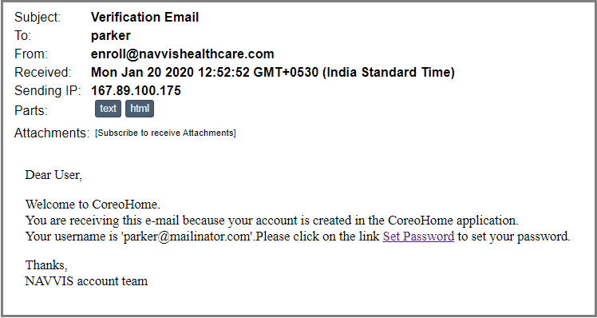

1. Email Verrification Link

# Patient Profile

Help your service providers to learn more about you by completing your profile. Add the following to your profile: your name, phone number, age, height, weight, emergency contact numbers, clinical conditions, languages spoken, and your guardian details.

Be sure to include a picture of yourself.

Your profile photo helps your service provider to know who you are. Upload a clear and recent photo so that it’s easier for the caregiver to recognize you.

## Edit Your Profile

When you sign in to your patient profile for the first time as a new user, Coreo Home takes you to the **Browser Provider** screen.

Follow these steps to edit your profile details:

1. Select the profile logo on the side menu.

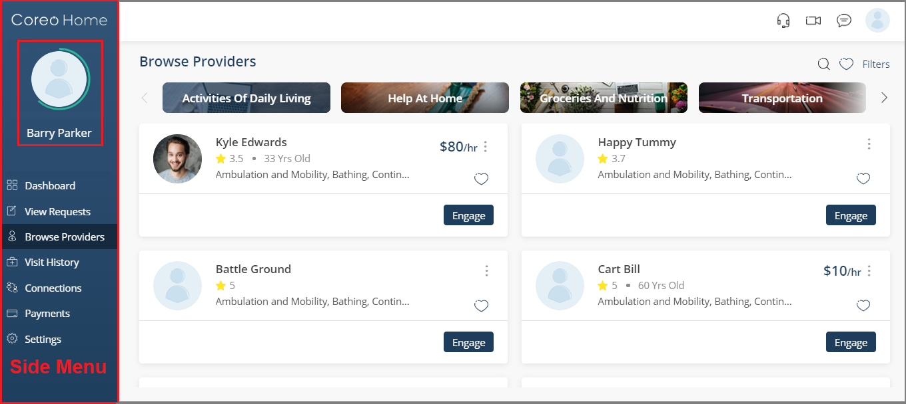

1. Browse Provideers screen
2. The Profile page opens.
3. Select the **Edit** button (pen icon) in the upper-right corner of the **Profile** page.

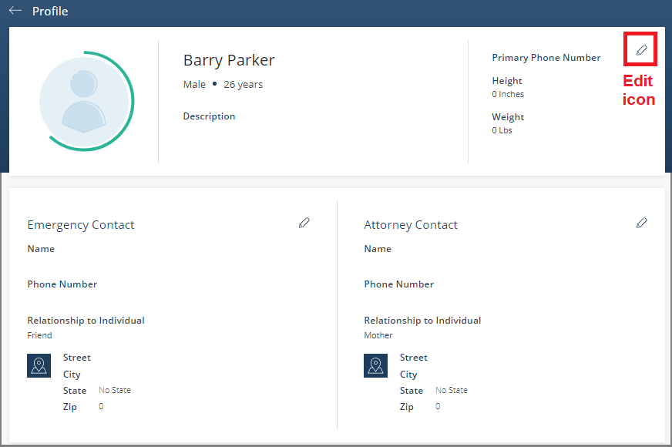

1. Profile page

The **Edit Personal Details** screen opens.

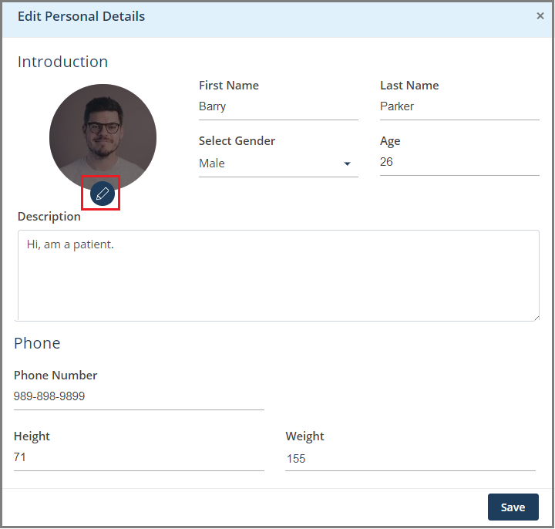

1. Edit Personal Details screen
2. Select the edit icon on the profile logo and upload your picture.
3. Enter the required details on the **Edit Personal Details** page such as name, gender, age, phone number, height (in Inches), and weight (in Lbs).

Phone number is necessary without which you will not be able to save the changes.

1. Select the **Save** button to save the changes that you made to your personal details and to go back to the **Profile** page.
2. Similarly, on the **Profile** page, you can update your emergency contact number and your attorney contact numbers.

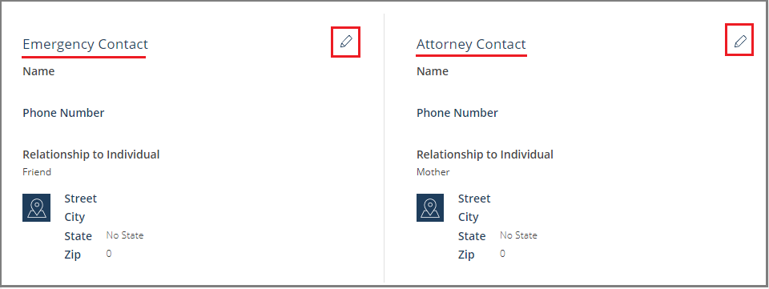

1. Profile page

Update your clinical conditions so that the service provider can send a caregiver based on your specialized needs as updated in this section.

1. On the **Profile** page, in the **Clinical Conditions** section, select the edit icon.

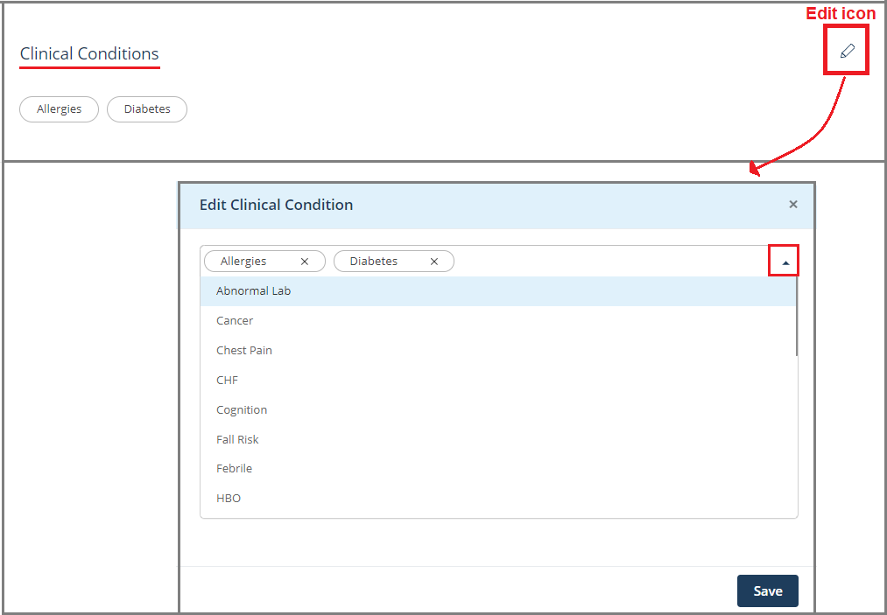

1. Profile page–Clinical Condition and Edit Clinical Condition page
2. Select the drop-down arrow and choose your clinical condition from the list.
3. Select the Save button in the **Edit Clinical Condition** page to updated the changes to the **Profile** page.
4. In the **Point of Service** section, select the Edit icon. The **Edit Point of Service** page opens.

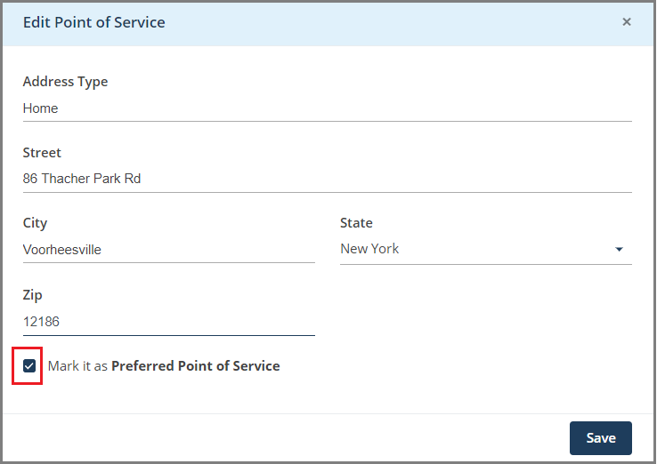

1. Edit Point of Service page
2. Enter your address details which includes **Address Type** (May include Home, Office, or Business), **Street** name, **City**, **State** name and the **Zip** code.
3. Select the **Mark it as Preferred Point of Service** check box to mark the address as your primary address where you would want your services to be offered.
4. Select **Save** to save the changes and go back to the **Profile** page.
5. Similarly, update your secondary address details.
6. In the **Languages Spoken** section on the **Profile** page, enter the languages that you know. This information helps the service provider to send a caregiver who can communicate with you in the languages of your choice.
7. In the **My Connections** section on the **Profile** page, you can add details of these members:

* **Individuals:** An individual is the one for whom you are the guardian. You can be a guardian for more than one individual.
* **Guardians:** Your guardian. You, as an individual can have more than one guardian.

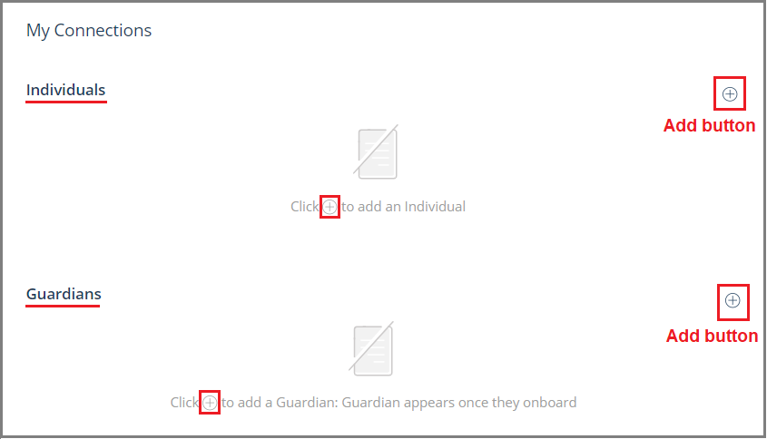

1. Profile page–My Connections section
2. To add an individual that you wish to be the guardian for, select the plus icon button for **Individuals**. The **Add an Individual** page opens.

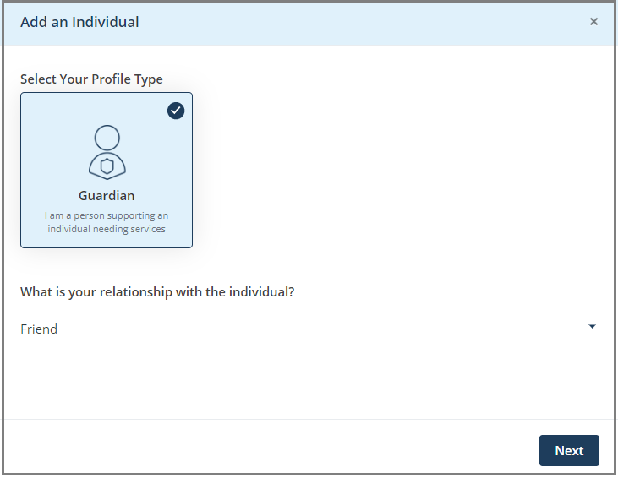

1. Add an Individual page
2. Select the **Guardian** profile type.

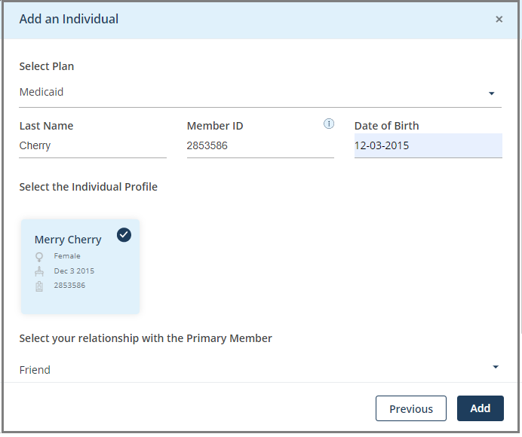

1. Select your relationship with the individual whom you want to be the guardian for and then select **Next**.
2. Select the type of plan in the **Select Plan** box from these options:

* **Commercial**
* **Medicaid**
* **Medicare**
* **Not in List**

1. Enter the individual’s last name, member id and the date of birth. The member id identifies the HMSA membership and enables providers to determine the plan benefits.
2. Select the **Search** button to search the individual based on the details that you have entered. The individual’s profile displays.
3. Select the individual profile. A tick mark displays indicating that you have selected the individual profile.
4. Select your relationship with the primary member and then select **Add**.
5. Select **Confirm** in the message box to proceed with adding the individual.

The individual is added to your profile page.

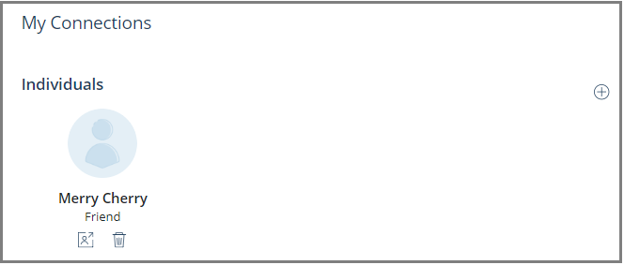

1. Profile page–Individual added to your (patient) profile
2. To add your guardian, select the Add button under **My Connections** on the **Profile** page. The **Add Guardian** page opens.

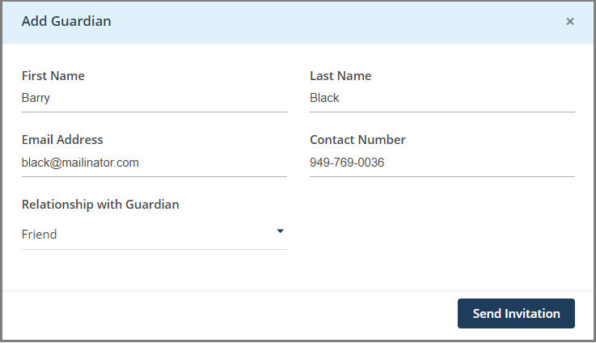

1. Add Guardian page
2. Enter these details: The guardian’s first name, last name, email address, contact number and your relationship with the guardian.
3. Select the **Send Invitation** button to send an email-invite to your guardian to create a guardian account in Coreo Home.

Once your guardian accepts the invite, Coreo Home takes the individual through a series of steps to onboard your guardian to the Coreo Home-Guardian account.

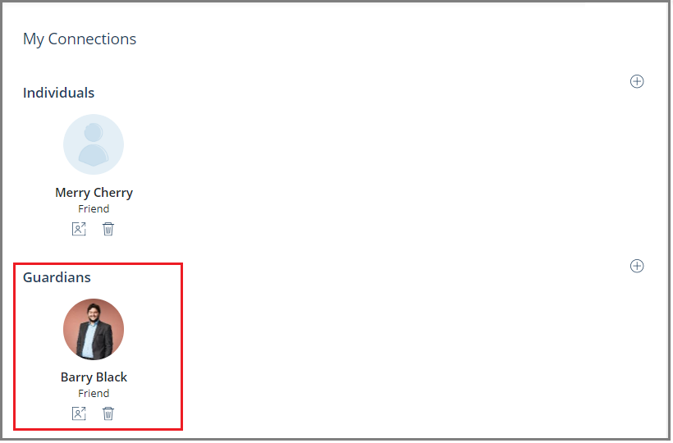

1. Profile page–Guardian added to the your (patient) profile

Once your guardian has onboarded successfully, you can view your guardian details on your profile page.

# Set Up Payments

Follow these steps to set up your payment cards to be able to make payments to your service providers:

1. On the side menu, select **Payments** to open the **Payments** screen.

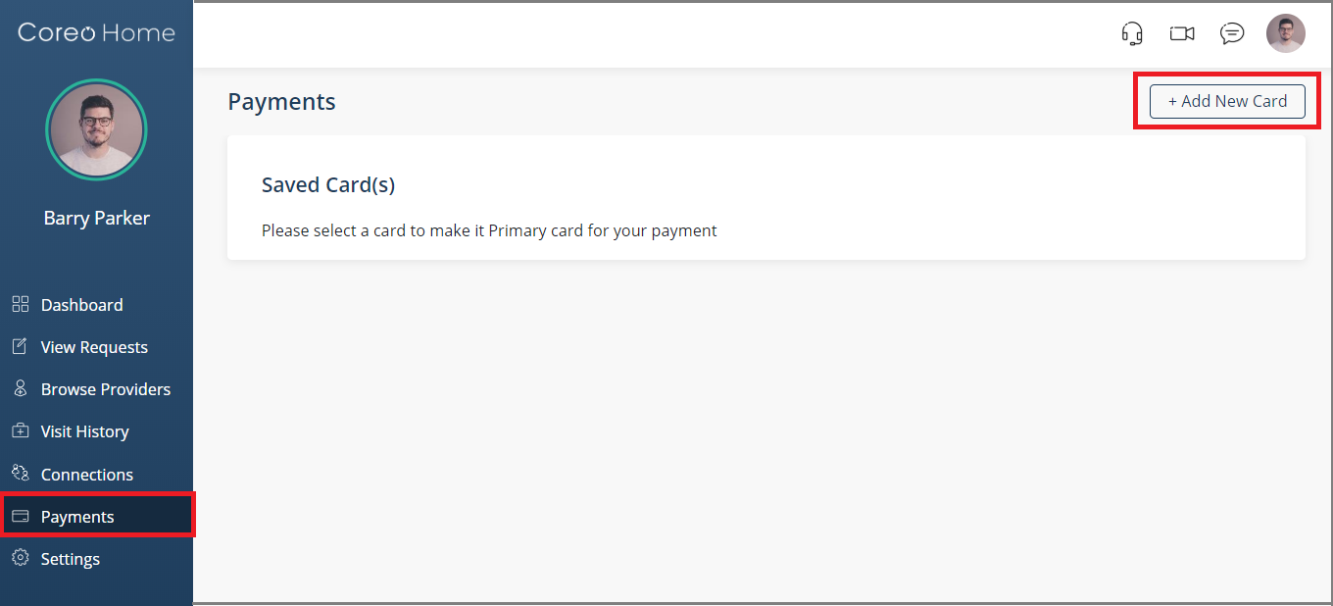

1. Payments screen
2. Select the **Add New Card** button to open the **Add New Card** window.

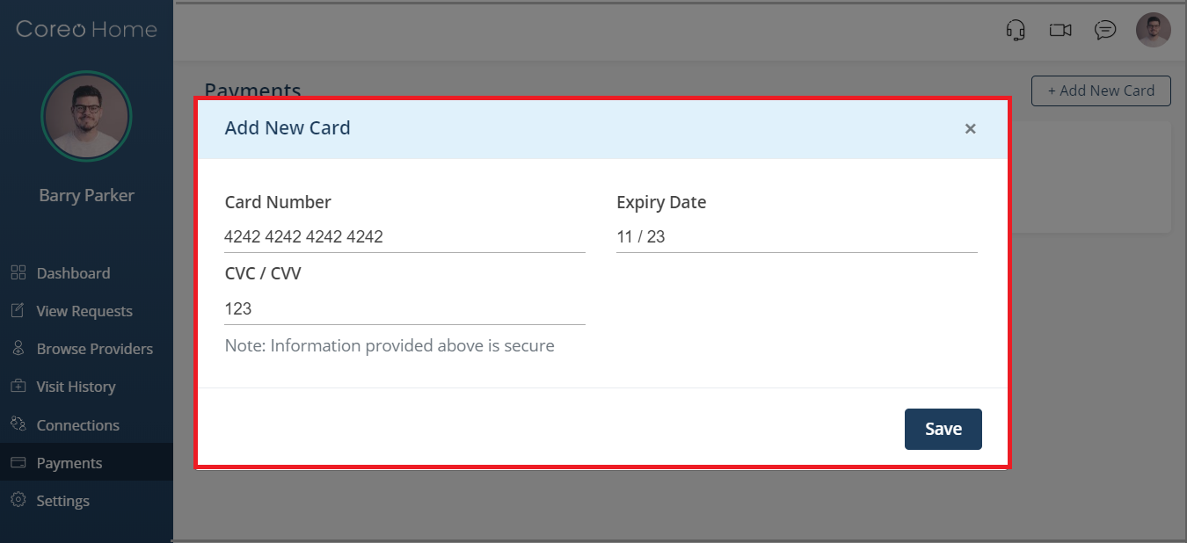

1. Add New Card window
2. Enter the card number, the CVC/CVV number and the card expiry date of your payment card.
3. Select **Save** to save the card details.

A message box displays indicating that you have successfully saved the card.

You can view the saved card.

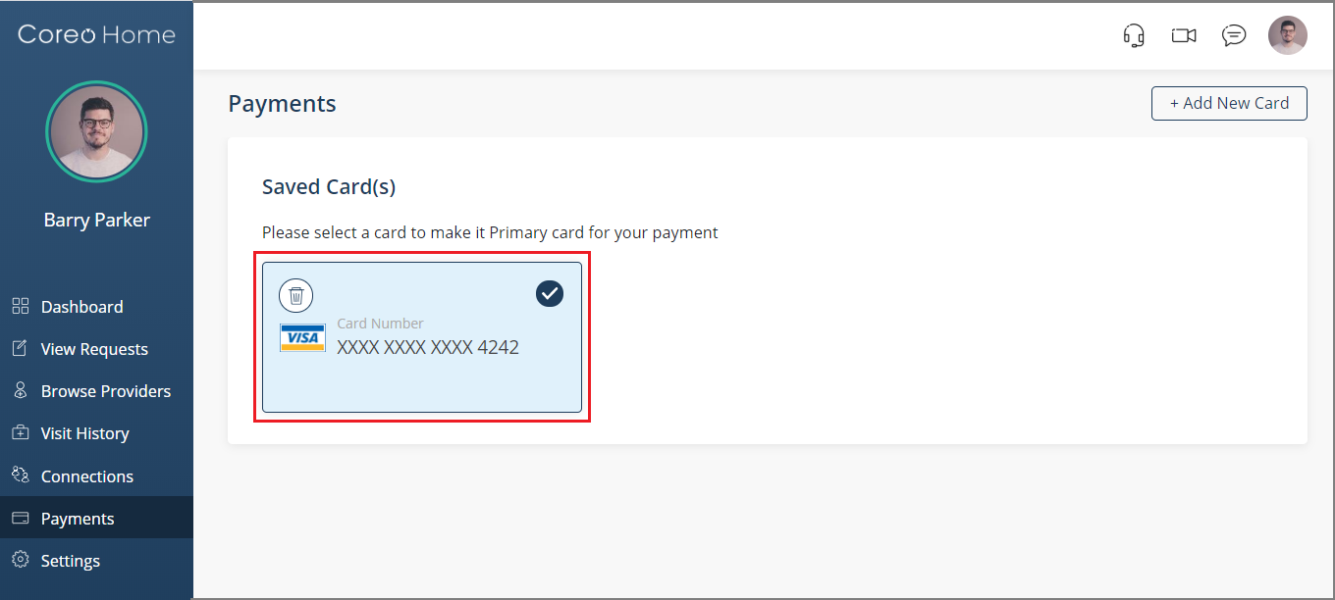

1. Payments-saved card
2. To add multiple payment cards, select the **Add New Card** button and repeat the process to save another card.

|  |  |
| --- | --- |
|  | You cannot engage with individual service providers without saving your payment card. |

# Dashboard

Your dashboard is the main screen you see when you sign in to Coreo Home as an existing user.

When you sign in for the first time as a new member, Coreo Home takes you to the **Browse Providers** screen. You can navigate to the dashboard from the side menu.

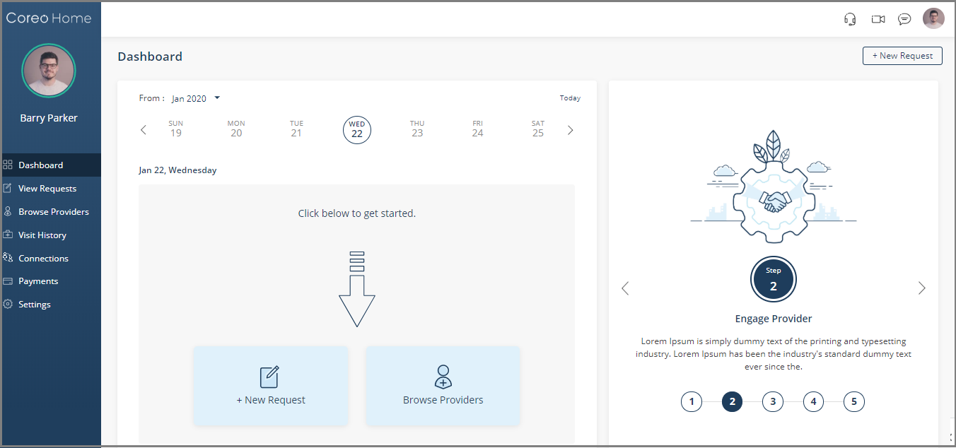

1. Dashboard screen-before creating service requests

The dashboard has two sections:

Calendar Panel

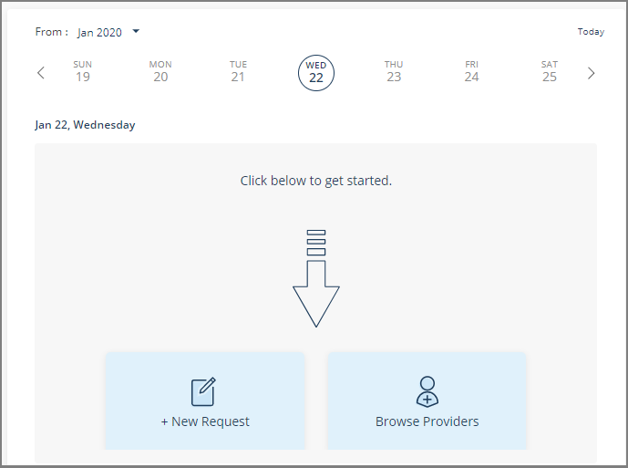

1. Calender panel

* Create a new service request using the **New Request** button in this section when you have signed in to Coreo Home as a new member;
* Look through the available service providers by using the **Browse Providers** button.
* If you have created service requests, track your service visits collectively in this section.

Wizard Panel

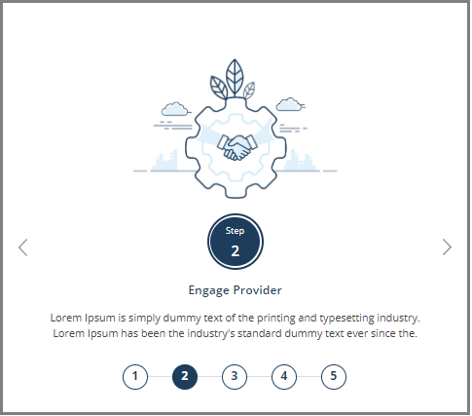

1. Wizard panel

* The wizard guides you through a sequence of stages to create a service request.
* When you sign in for the time, you are on the **Browse Providers** page, which is stage 1 of creating the service request. When you sign in next time, Coreo Home takes you to the **Dashboard** screen.

Browse Providers

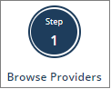

Follow these steps to search for the service providers:

1. On the side menu, select **Browse Providers** to open the **Browse Providers** screen.

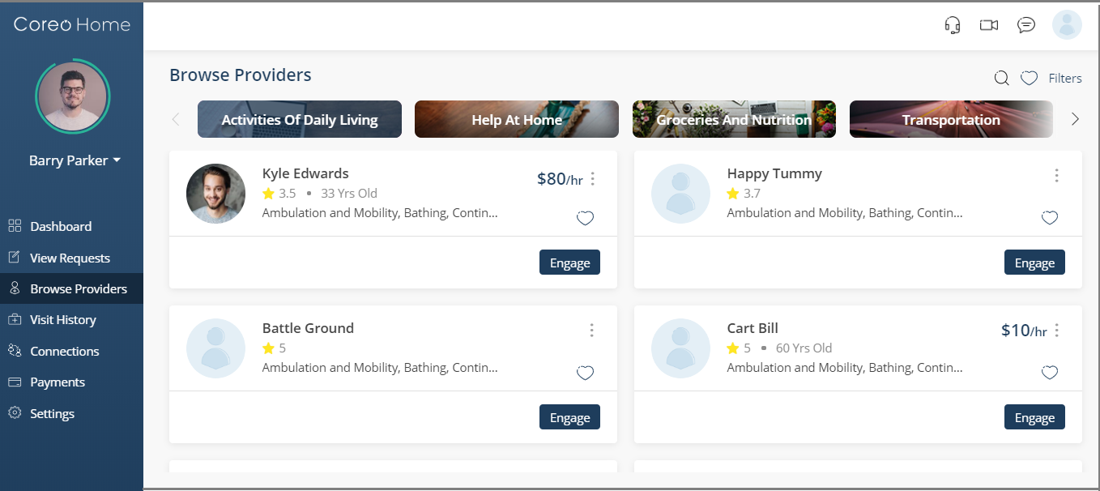

1. Browse Providers screen
2. Choose the service categories from these tabs:

* **Activities Of Daily Living**
* **Help At Home**
* **Groceries And Nutrition**
* **Transportation**

On selecting each of the above tabs, the vendors who offer the related services under each category are listed.

1. Click the service provider’s name or the profile picture to view the profile details, types of services offered, service location, available time and slots among others.

Engage Provider

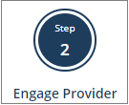

1. Choose the required service provider on the **Browse Providers** screen.
2. Select the **Engage** button. The **Create New Service Request** screen opens.

Create and Post a Service Request

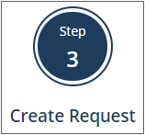

Coreo Home takes you through four steps on the **Create New Service Request** screen to hire a service provider.

1. **Service**
2. **Preference**
3. **Questionnaire**
4. **Review**

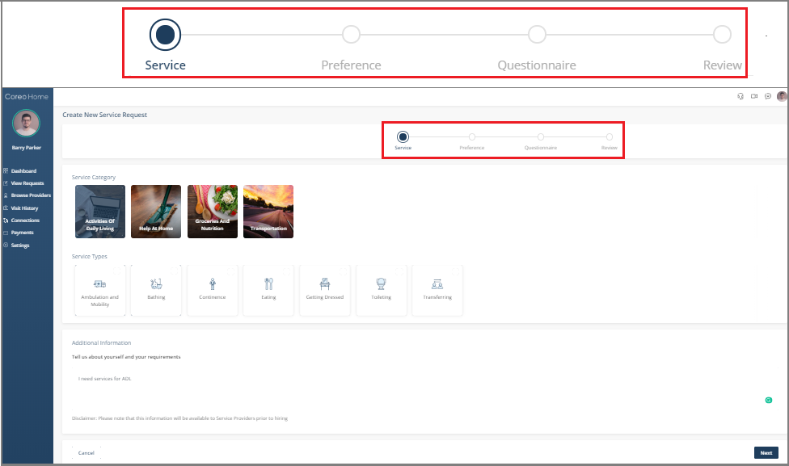

1. Create New Service Request screen

Service

1. Select the **Service Category** from the following:

| * **Activities Of Daily Living:** |  |
| --- | --- |
| * **Help At Home**: |  |
| * **Groceries And Nutrition**: |  |
| * **Transportation**: |  |

**Activities Of Daily Living** is the default service category and under each of the four service categories, the related service types are listed.

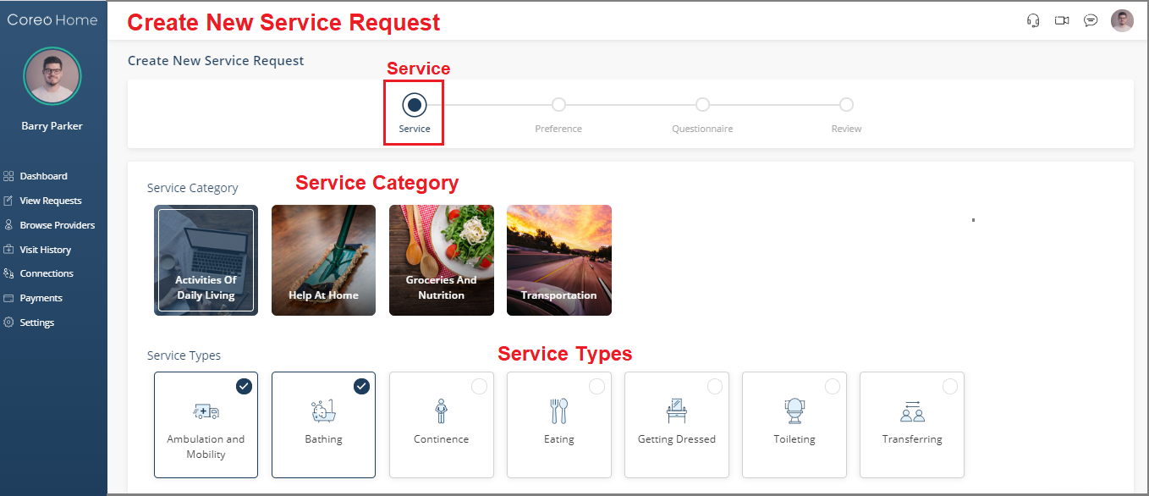

1. Create New Service Request screen–Service page
2. Choose the service types. *For example, you can choose* ***Ambulation and Mobility*** *and* ***Bathing*** *which**are**two of the service types under the* ***Activities of Daily Living****.*
3. *Similarly, under the* ***Help At Home*** *service category, choose the service types* ***Companionship and Errands****,* ***Food Prep****, and* ***House Keeping****.*
4. Enter the additional information about yourself or about your requirements, if required.
5. Select the **Next** button.

Preference

The **Create** **New Service Request**–Preference page opens.

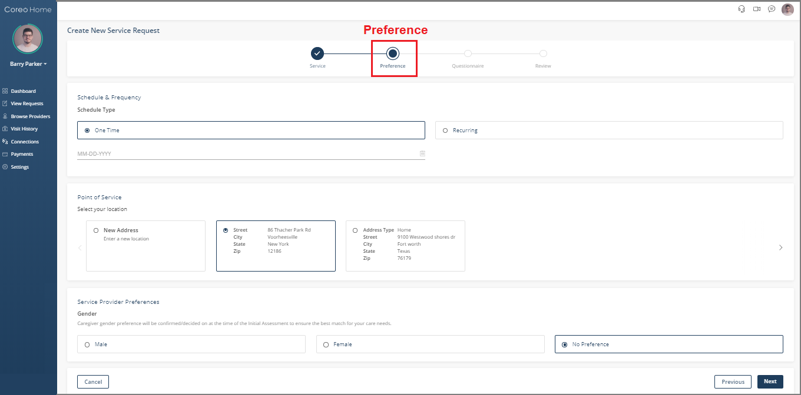

1. Create New Service Request screen–Prefernce page
2. Select the schedule type from these two options:

* **One Time:** Use this option to schedule a single-time service for a date of your choice. You can have a maximum of three slots or visits, **Morning**, **Afternoon**, and **Evening** for a **One Time** schedule type.
* **Recurring:** Use this option to schedule multiple visits at regular intervals until a date of your choice.

Schedule Type–One Time

Under the **Schedule Type**, **One Time** is the default selection.

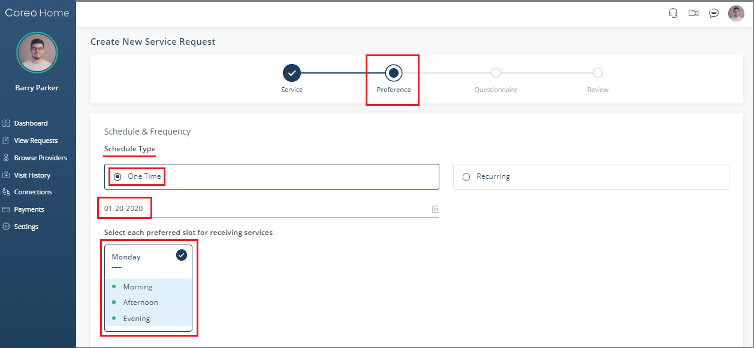

1. Create New Service Request screen
2. Select the calendar icon to select the preferred date.
3. Select the preferred slot for which you want to receive the services from these options:

* **Morning**
* **Afternoon**
* **Evening**

1. Scroll the screen down.
2. Select the location at which you want to receive the service under **Point of Service**.

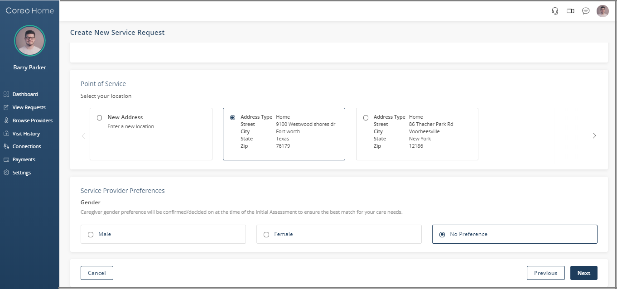

1. Create New Service Request screen
2. Select the gender preference of the caregiver from these options:

* **Male**
* **Female**
* **No Preference**

1. Select the **Next** button to open the Questionnaire.

Schedule Type–Recurring

Under the **Schedule Type**, select the **Recurring** button to schedule multiple visits periodically until a selected date.

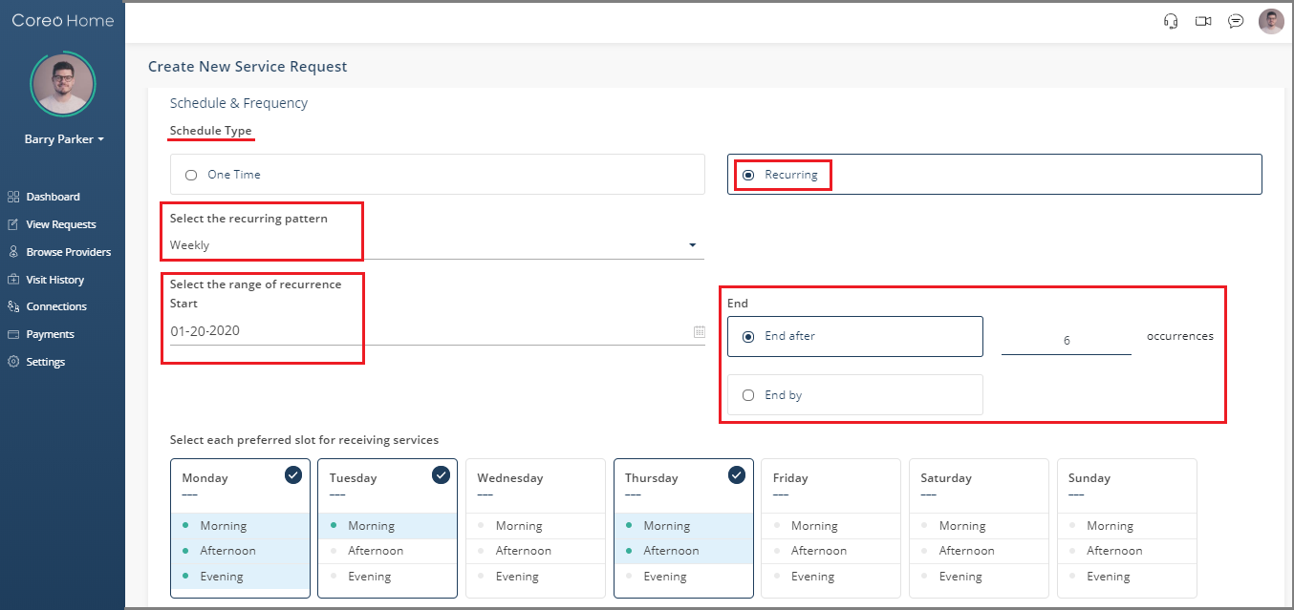

1. Create New Service Request–Schedule type-Recurring
2. Select the recurring pattern from one of these two options:

* **Weekly**
* **Monthly**

1. In the **Start** box, select the starting date of the recurrence period that you want to book the service for.
2. Select the end date of the recurrence period from one of these two options:

* **End after**: Your service period ends after the number of occurrences that you have entered here.

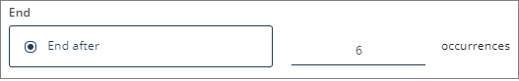

* **End by**: Your service ends after the date that you have specified here.

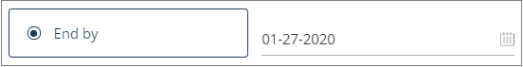

1. Select the preferred slots for which you want to receive the services:

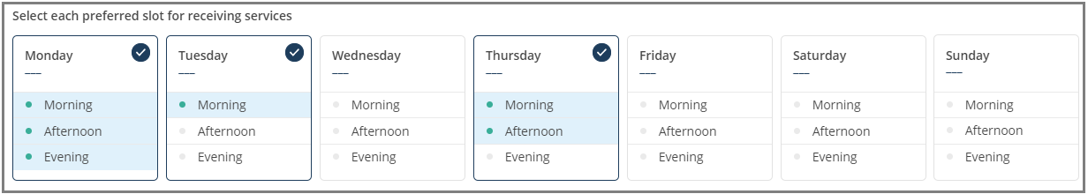

***Example****: You enter 6 occurrences and select 6 slots (Monday – Morning, Afternoon, Evening; Tuesday – Morning; and Thursday – Morning, afternoon), then the service visit begins from the start date that you have given and you would be receiving the visits for the selected slots.*

If you select lesser number of slots than the number of occurrences, the remaining slots are serviced the following week.

***Example****: You enter 6 occurrences and select only 3 slots (Monday – Morning; Tuesday – Morning; and Wednesday – Morning), the remaining 3 slots are serviced the next week in the same pattern (Monday – Morning; Tuesday – Morning; and Wednesday – Morning).*

Similarly, if you select the **Monthly** option, you shall receive the service for the slots that you select on a periodic basis, based on the number of occurrences or on the end-by date.

Questionnaire

1. Fill in the questionnaire to help the caregiver provide you better service based on the answers that you give in the questionnaire.

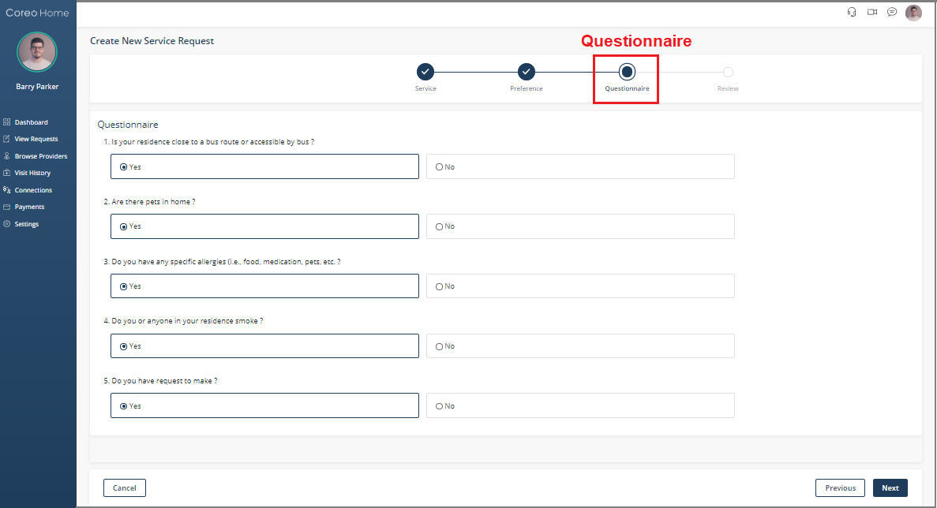

1. Create New Service Request screen–Questionnaire
2. Select the **Next** button to open the **Review** screen.

Review

1. Go through the details that you have provided in the previous three stages on the Review page.

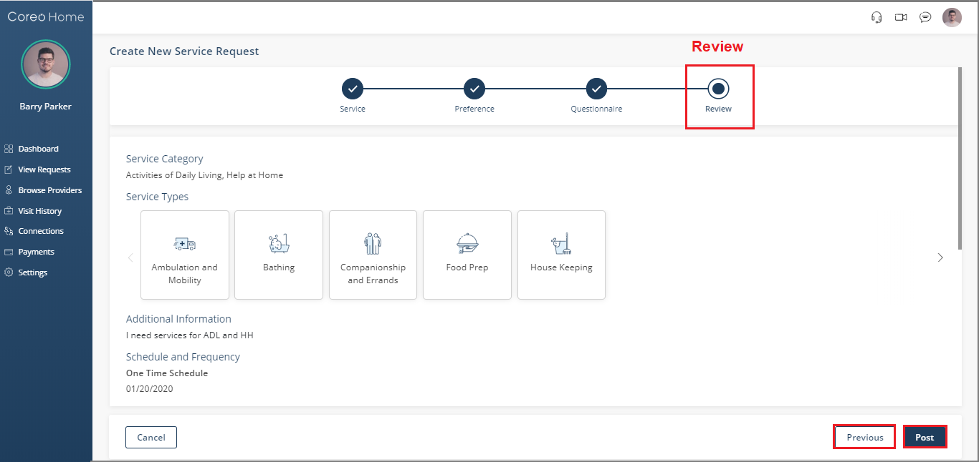

1. Create New Service Request–Review
2. If you want to make any changes in your previous selections, select the **Previous** button and make the required changes.
3. Select the **Post** button to post the service request that you have created.

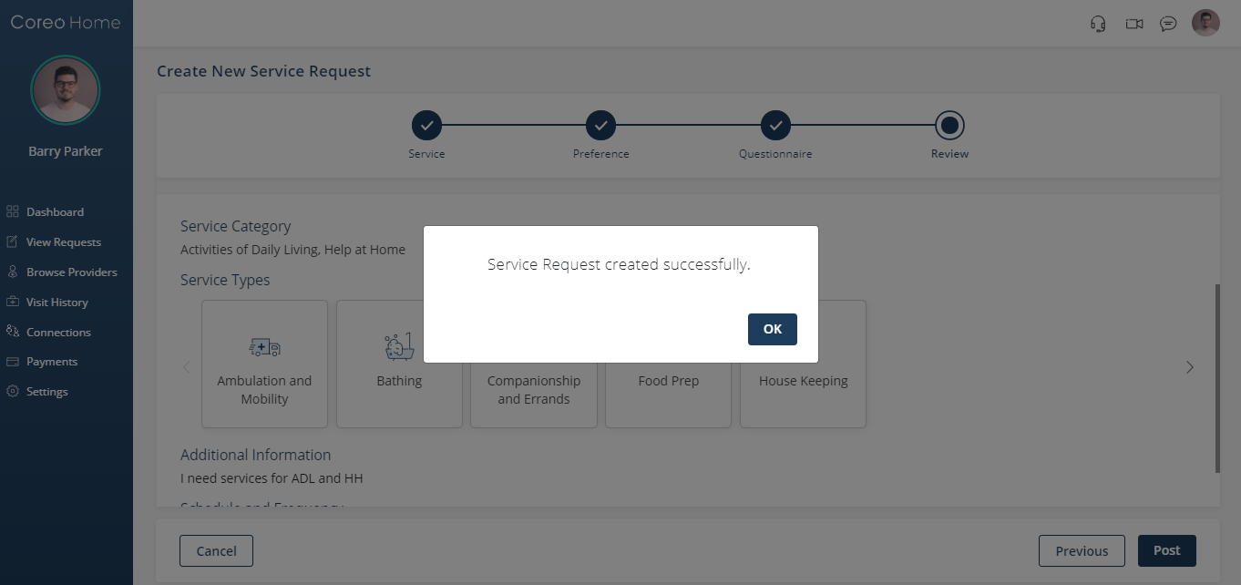

1. Select the **OK** button to go to the **View Requests** screen.

Visit(s) Schedule

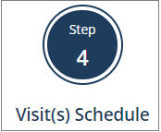

You can also open the **View Requests** screen by clicking the **Visit(s) Schedule** button in the wizard on the dashboard.

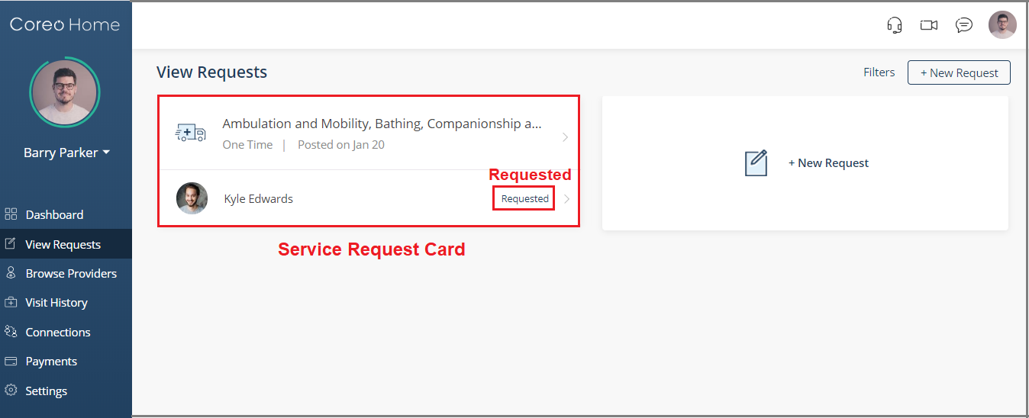

1. View Request screen–status-Requested

Notice that the Service Request (SR) card displays the status **Requested** when your service request is not accepted by the service provider, yet. The status changes to **Engaged** when your service provider accepts your service request.

You can also create a new service request from these places:

|  |  |
| --- | --- |
| * **New Request** button on the header bar |  |
| * **Create New Request** button from the wizard |  |
| * **New Request** button on the **View Request** page |  |

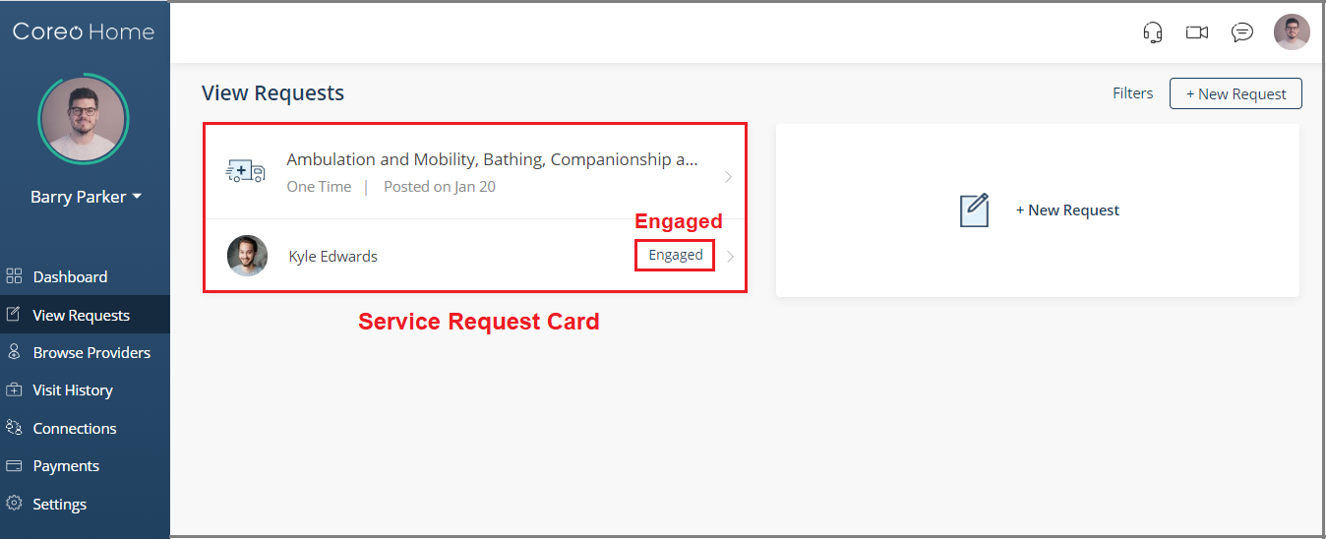

1. View Request screen–status-Engaged

When you create a new service request directly without engaging a specific service provider, an open request is created. The status of the service request card is **Open**.

1. Select the SR card to view the details under the **Request** tab, **My** **Plan** tab and the **Provider** tab.
2. View details such as the service category, service types, schedule and frequency, and the point of service that you had selected for the service visits.

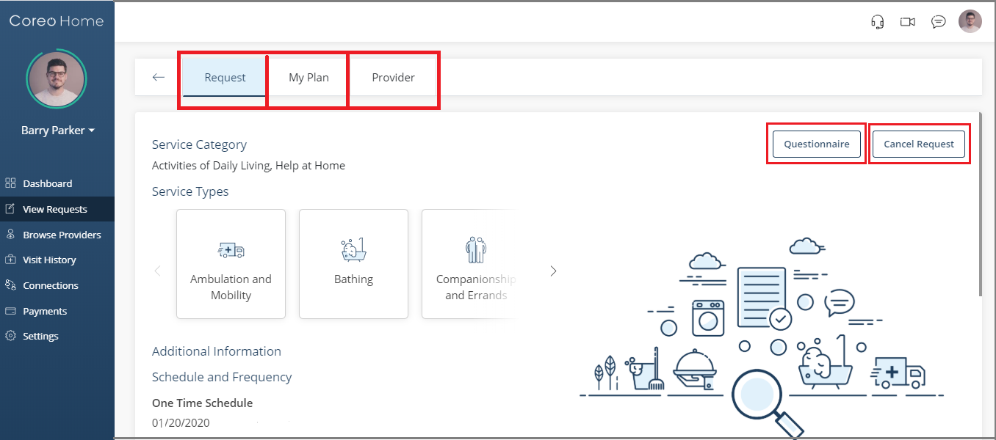

1. Request tab page
2. At any point in time, you have the flexibility of cancelling the scheduled visit by selecting the **Cancel Request** button.
3. Select the **My Plan** tab to view the scheduled visits.

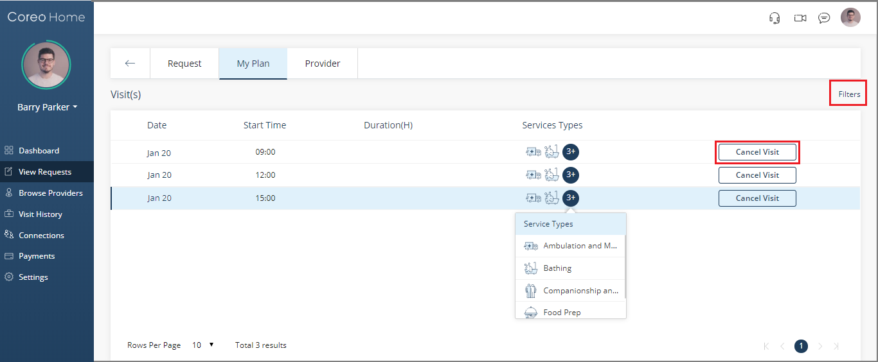

1. My Plan tab page
2. Select the **Filters** buttonto filter the visits based on the visit-date or the status of the service requests.

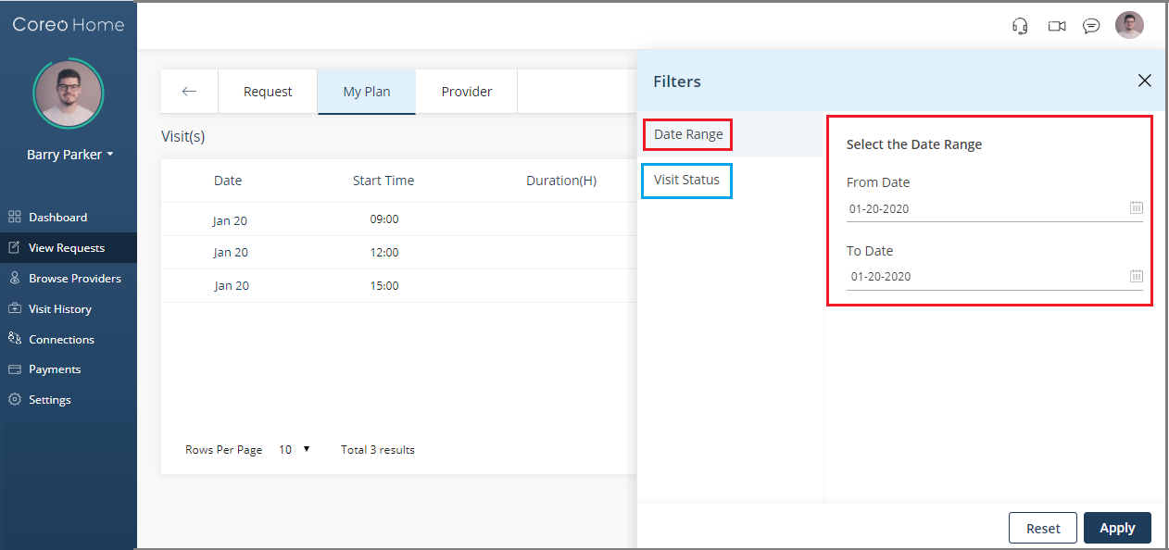

1. On the **Filters** page, select the **Date Range** button to filter the visits based on the visit-date.
2. Select the **Visit Status** button to filter the SRs based on these options:

* **Scheduled**
* **In Progress**
* **Completed**
* **Cancelled**
* **Payment Pending**

1. Select **Apply** to apply the filter criteria. You can use the Reset button to remove the filter.
2. On the **My Plan** tab page, the status changes to **In-Progress** when the caregiver has started the service visit.

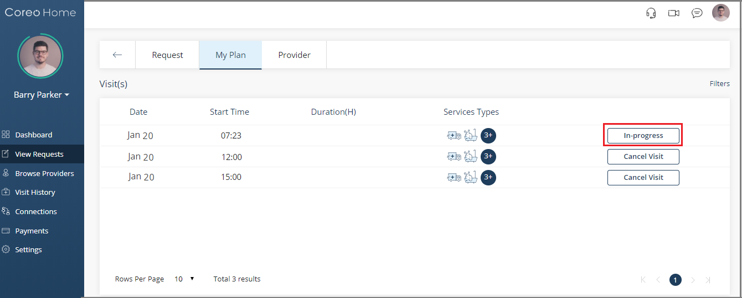

1. My Plan tab page– visit status-In Progress

When your caregiver completes the service task, the visit status changes to **Payment Pending** and you can view the duration of the service in hours.

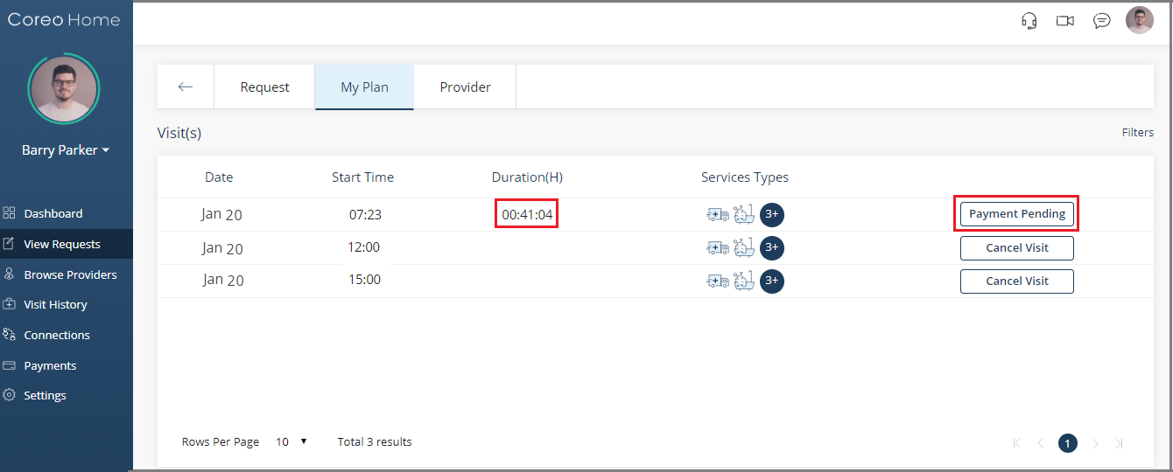

1. My Plan tab page–visit status-Payment Pending
2. Select the **Payment Pending** button to open the **Service Requests**–Summary page.

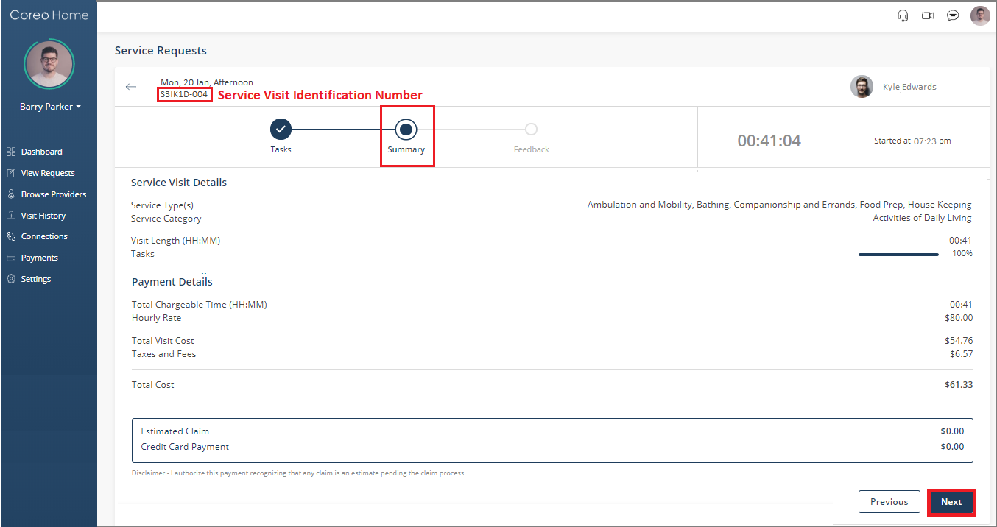

1. Service Requests page–Summary page
2. View the service visit details such as duration of the service, the total cost and the payment amount that is due to the provider. The service visit identification number helps you track the visit details.
3. Select the **Next** button. The **Feedback** page opens.

Submit Feedback

You can skip the feedback-step, however it is recommended that you provide the feedback so that the service provider can evaluate the caregiver based on your feedback and provide your better service in the future.

1. On the **Feedback** page, select from the choices in the questionnaire to give your feedback on the previously received service.

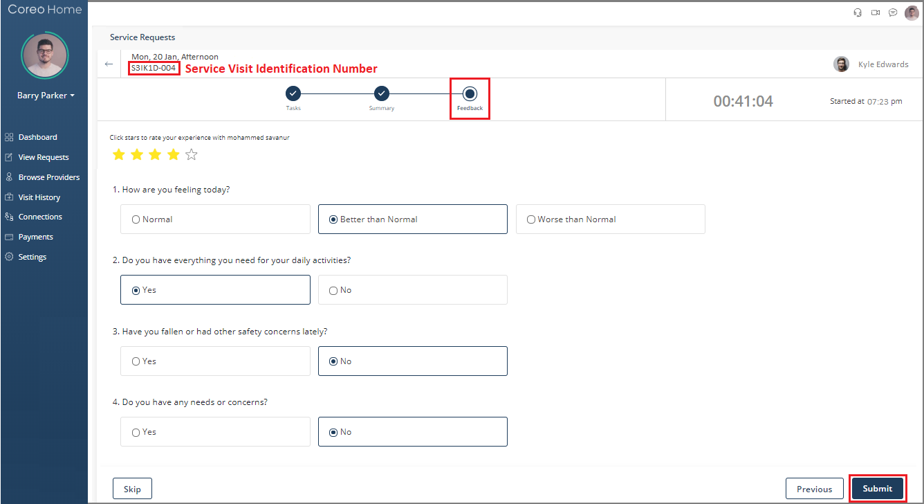

1. Service Request–Feedback page
2. Select the **Submit** button.

When you make payment to your service provider and your service provider processes your payment from their Coreo Home account, the status of the service visit changes to **Visit Summary**.

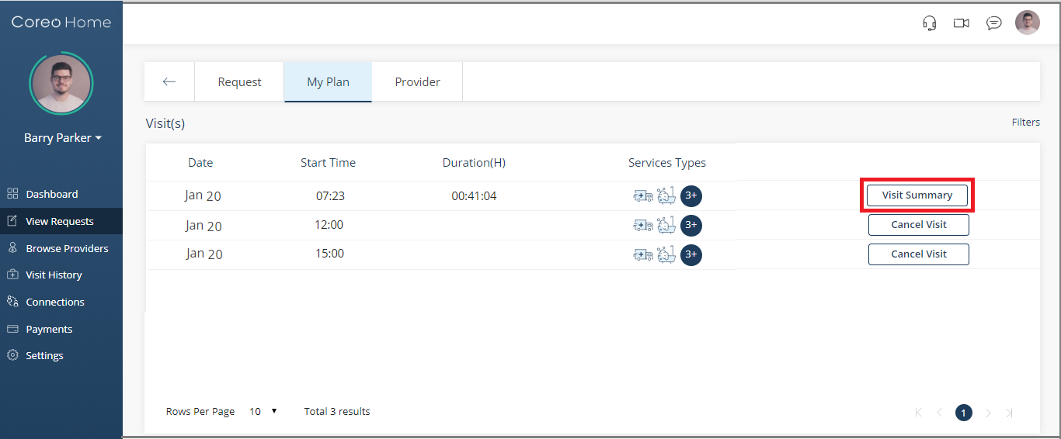

1. My Plan tab page– visit status-Visit Summary
2. Select the **Visit Summary** button to open the **View Request** page to view the service details and the payment details.

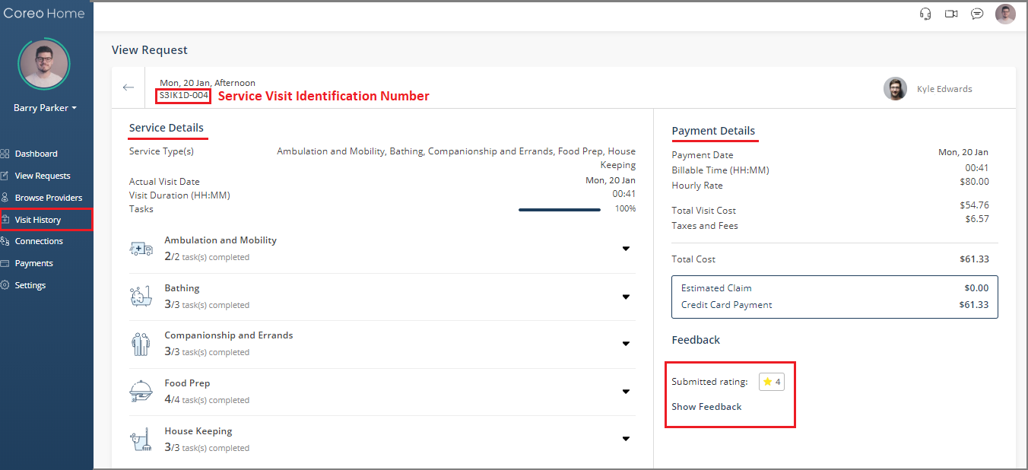

1. View Request page

The service visit identification number helps you track the visit details.

You can also visit the **View Request** page by selecting the **Visit History** on the side menu and then clicking the arrow of the related service visit card.

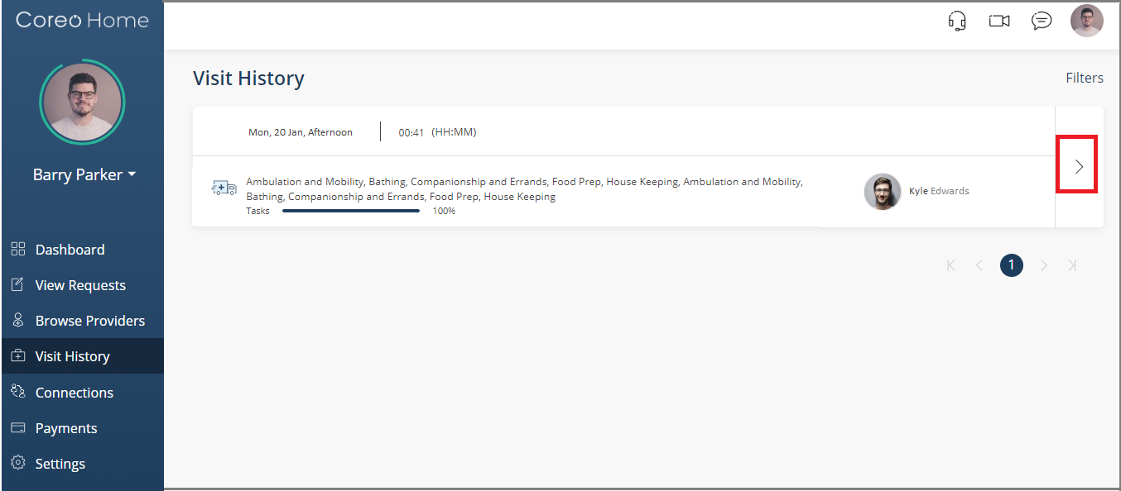

1. Visit History page–service visit card

You can also submit the feedback of the service visit from the wizard on your dashboard.

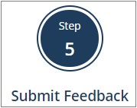

1. Go to the dashboard and select the **Submit Feedback** button in the wizard.
2. The **Visit History** page opens. Click the arrow of the respective service visit card to open the **View Request** page.

If you have not submitted your feedback yet, you can submit it under the **Feedback** section on the **View Request** page.

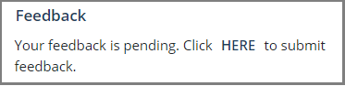

However, if you have already submitted the feedback on the **Service Requests** page, you can view the submitted feedback by clicking **Show Feedback**.

# Header Bar

The header bar has the following elements on its right-hand side:



* Headset icon: Use this to access the Coreo Home user help content.
* Video icon: Use this to do video conferencing with your service providers or guardians or dependent members.
* Message icon: Use this to have text conversations with other members.
* Profile icon: Use this to edit your profile, or to watch the introduction video and to sign out from your profile.

## Video Conferencing

Use the video conferencing feature to connect with your care givers remotely for advice, care, reminders, monitoring and for other communications.

Follow these steps to video conference with your service providers and guardians:

1. On the upper-right corner of the Coreo Home screen, select the video conferencing icon.



1. Video Conferencing icon

The **Video Conference** window opens.

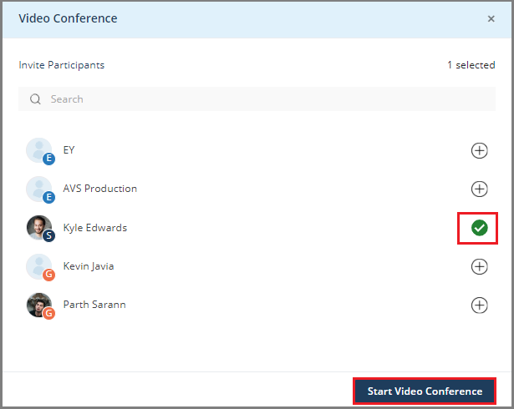

1. Video Conference window
2. Select one or more participants with whom you want to connect through video conference. A green tick mark displays which helps you identify the selected participants.
3. Select the **Start Video Conference** button.

## Messaging

Use the messaging feature in Coreo Home to share information quickly by sending and receiving messages with other members.

Follow these steps to have text conversations with your service providers or with your other connections like guardians:

1. On the upper-right corner of the Coreo Home screen, select the conversation icon.

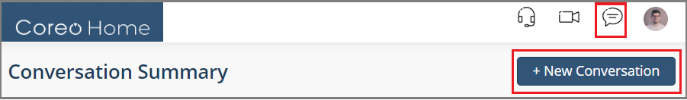

1. Conversation icon
2. Select the **+New Conversation** button.

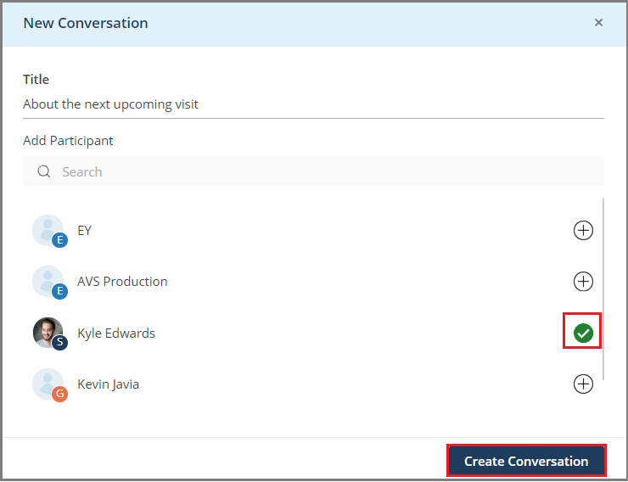

1. New Conversation window

The **New Conversation** window opens and your connections and the service providers that you are engaged with are shown under the participants with whom you can engage in a conversation.

1. Enter the title of the conversation. You can edit the title any time during an ongoing conversation and select the tick button to save the edits.
2. Select one or more participants with whom you want to converse. A green tick mark displays which helps you identify the selected participants.
3. Select the **Create Conversation** button. The **My Conversations** page opens.

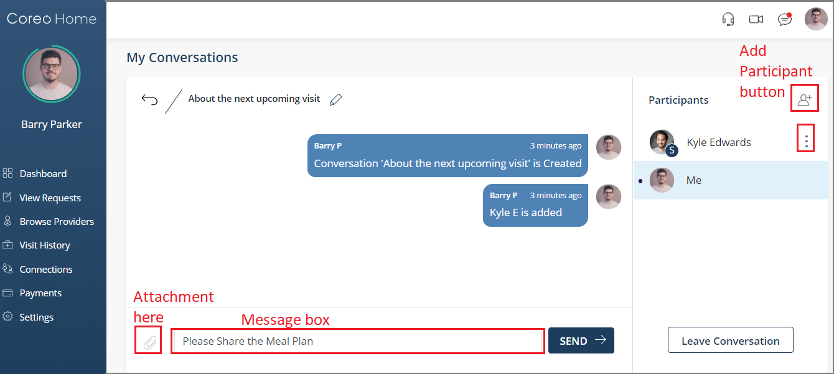

1. My Conversations page
2. Key in your message in the message box and select the **Send** button. You can add attachments too.
3. On the right-hand side of the screen, select the add member icon to include more participants in your conversation, if required.
4. Next to each participant’s name, you can select the three vertical dots to either view the participant’s profile or to remove the participant from the conversation.
5. Select the **Leave Conversation** button to quit the conversation at any given point.

# Change Settings

You can modify the push notification and email notification settings when using Coreo Home on your mobile devices.

1. On the side menu, select **Settings**. The **My Settings** page opens

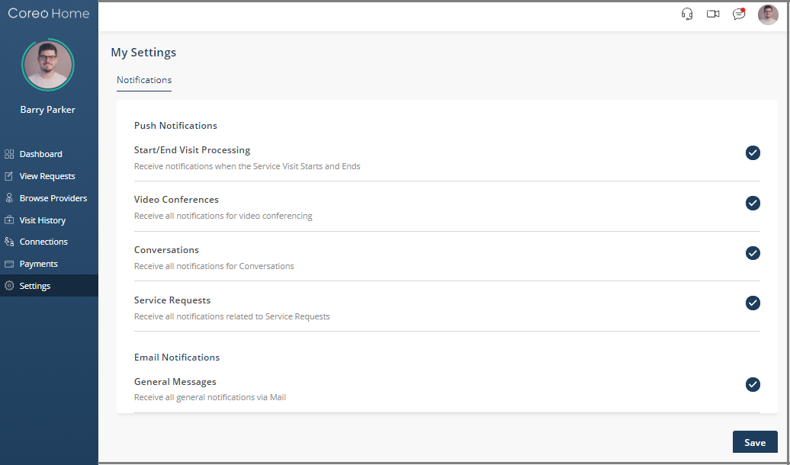

1. Change the notification settings as required and select the **Save** button to save the changes.

Coreo Home–Guardian Account

# Guardian Onboarding

# Guardian Profile

Follow these steps to edit your (guardian) profile details:

1. On the Coreo Home page, select the profile icon in the upper-right corner on the header bar, and then select the **My Profile** option.

Or, on the side menu, select the name arrow to open the drop-down list, and then select the **Me** option.

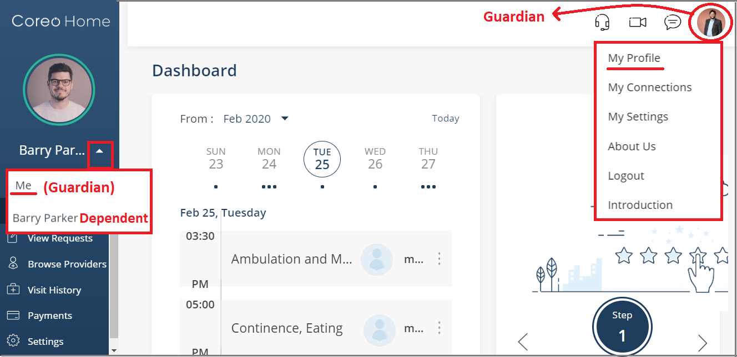

1. Coreo Home home page

The **Profile** page of the guardian opens.

1. Select the **Edit** button (pen icon) in the upper-right corner of the **Profile** page.

The **Edit Personal Details** screen opens.

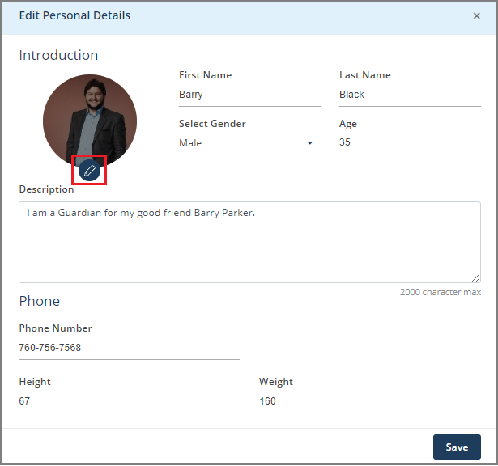

1. Edit Personal Details screen
2. Enter the required details on the **Edit Personal Details** page such as name, gender, age, phone number, height (in Inches), and weight (in Lbs).

Phone number is necessary without which you will not be able to save the changes.

1. Select the **Save** button to save the changes that you made to your personal details and to go back to the **Profile** page.
2. Similarly, on the **Profile** page, you can update your emergency contact number and your attorney contact numbers.
3. In the **My Connections** section, select the plus mark (Ꚛ) next to **Individuals**. The **Add an Individual** page opens. You can also directly access the **My Connections** section from the Coreo Home page by selecting the profile icon in the upper-right corner on the header bar, and then selecting the **My Connections** option.

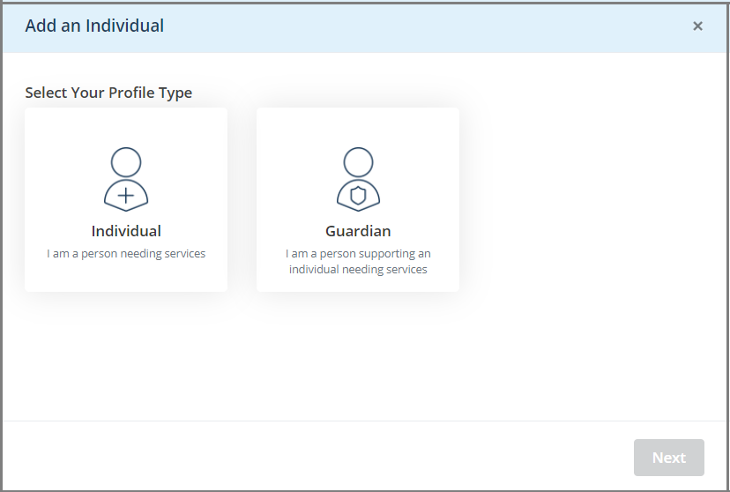

1. Add an Individual page

you can add details of these members:

* **Guardian:** You can be a guardian for more than one individual, and so can add one or more individuals whom you want to become the guardian for.
* **Individual:** Select this option if you (guardian) want to become the member who would need services. The guardian who is also a patient(individual) is referred to as an Individual-Guardian. The guardian account changes to the patient account.

## Guardian–Be a Guardian to the Individual that You Add

You can become a guardian to one or more individuals.

Follow these steps to add another individual:

1. Select the **Guardian** profile type on the **Add an Individual** page.

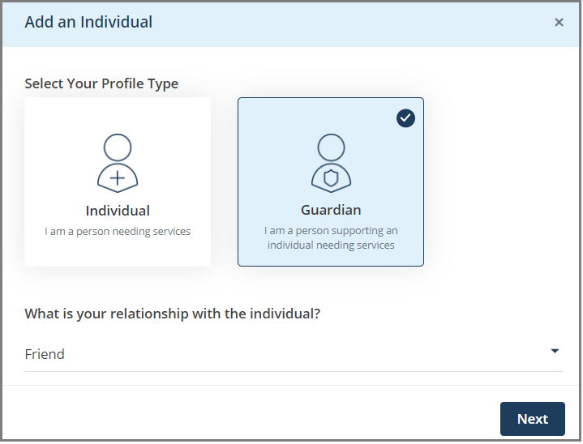

1. Add an Individual page–Guardian profile type
2. Select your relationship with the individual whom you want to be the guardian for and then select **Next** to navigate to the next screen.

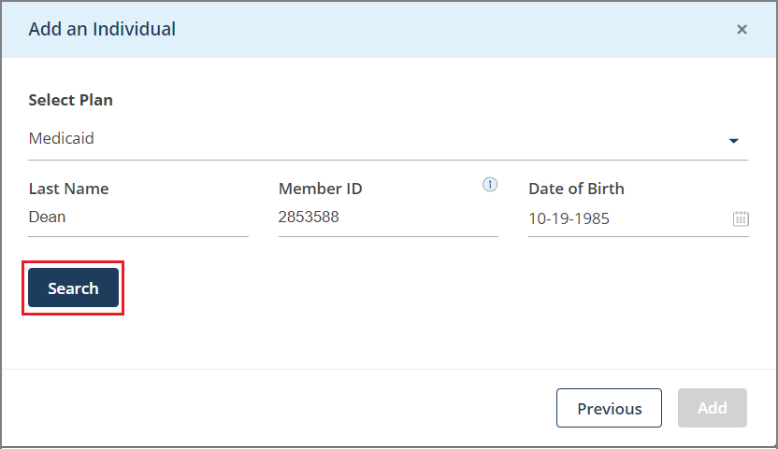

1. Add an Individual–select plan and the member
2. Select the type of plan in the **Select Plan** box from these options:

* **Commercial**
* **Medicaid**
* **Medicare**
* **Not in List**

1. Enter the individual’s last name, member id and the date of birth. The member id identifies the HMSA membership and enables providers to determine the plan benefits.
2. Select the **Search** button to search the individual based on the details that you have entered.

The individual’s name displays.

1. Select the individual profile. A tick mark displays indicating that you have selected the individual profile.

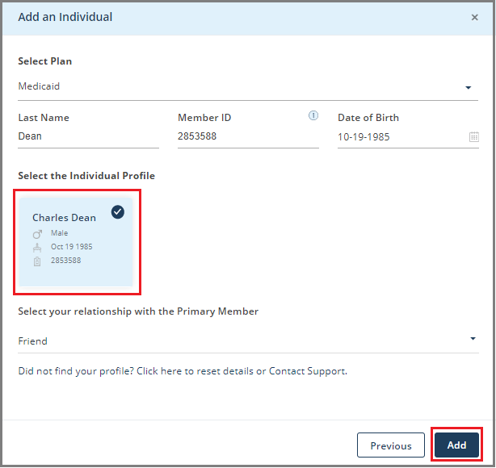

1. Select your relationship with the primary member and then select **Add**.
2. Select **Confirm** in the message box to proceed with adding the individual.

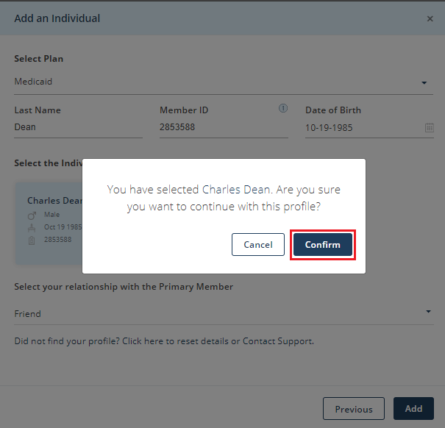

1. Confirmation box

The individual is added to your profile page.

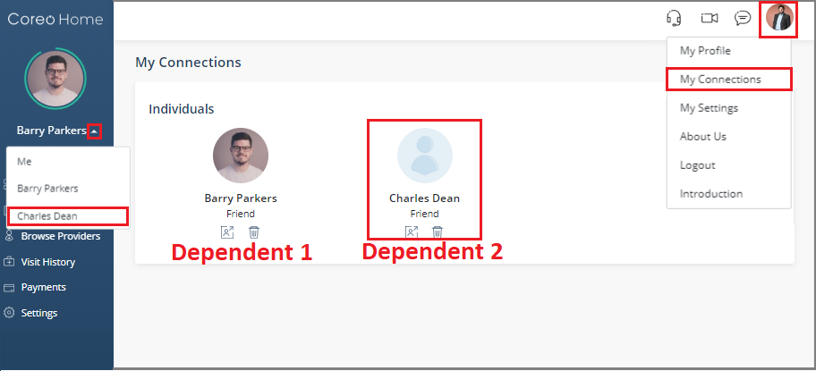

1. My Connections section
2. On the side menu, if you select the name arrow, you can view the individual that you just added.

## Individual–You are an Individual Needing Services

# Acting on Behalf of a Dependent Member

As a guardian, when you sign in to your account, you have access to your dependent member’s account.

On behalf of your dependent, you can do the following changes in your dependent’s Coreo Home patient account.

* Edit the profile details of your dependent member
* Set up payments
* Create and post service requests
* View requests
* Change settings

# Glossary

**Page**: The terms page and screen are used interchangeably in the context of the Coreo Home application.

**Caregiver**: The person sent by your service provider to assist you based on your service request and the type of service category.

**Individual**: A patient or a dependent member in need of services.

Index

[Depending on the size or complexity of the final document, insert an index to assist the user in locating specific information. Index entries correspond to tags or categories, and are useful in navigating long books.]

[Index term – *page number*]

[Index term – *page number*]

[Index term – *page number*]

[Index term – *page number*]

[Index term – *page number*]